Python中的GUI：图形编程、图形对象、交互式GUI

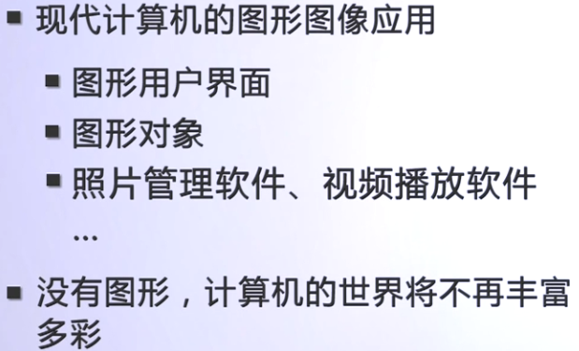

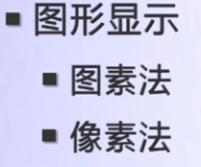

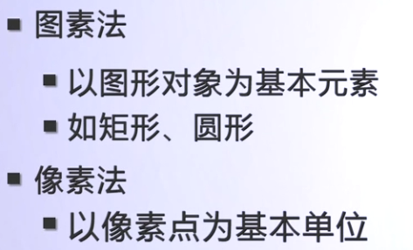

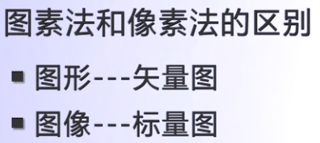

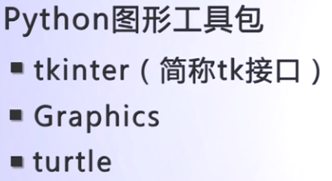

# 图形用户界面GUI

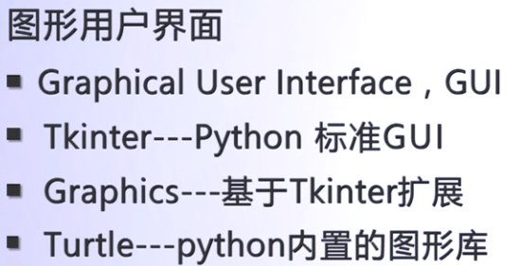

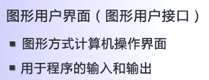

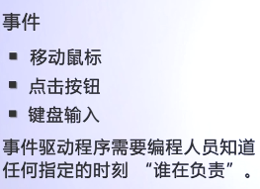

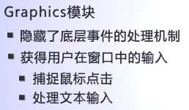

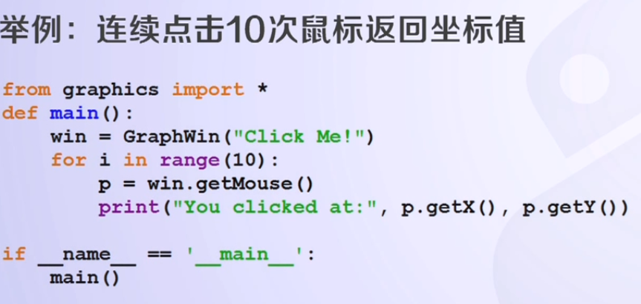

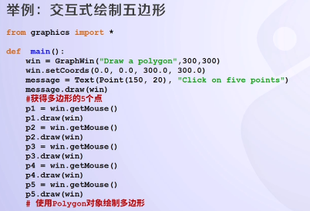

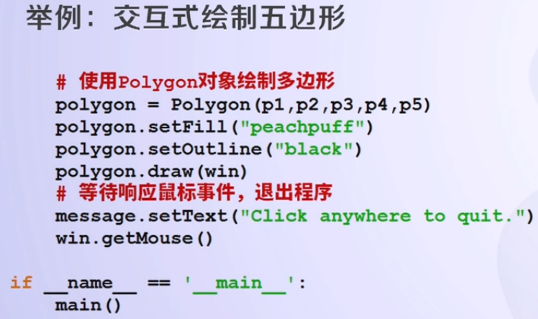

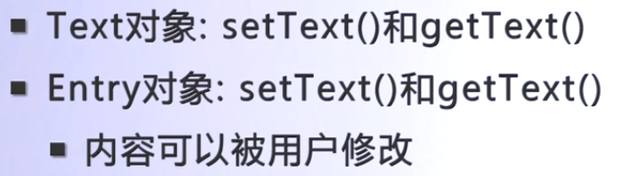

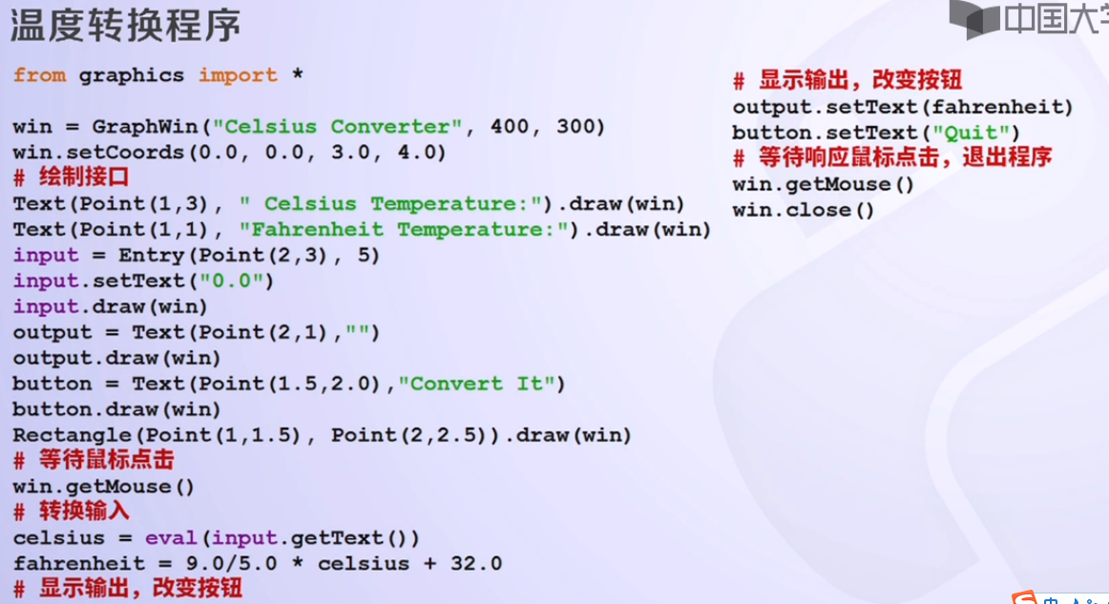

# Tkinter模块

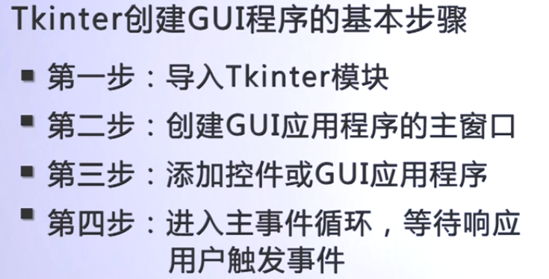

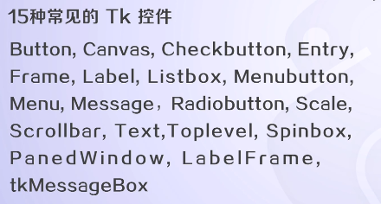

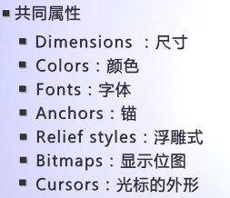

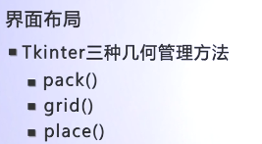

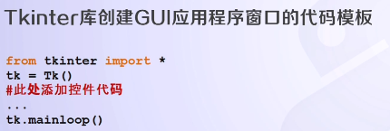

## 实例：

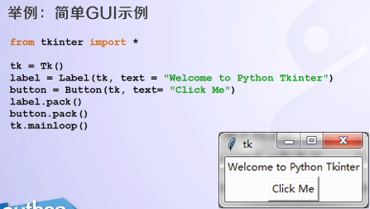

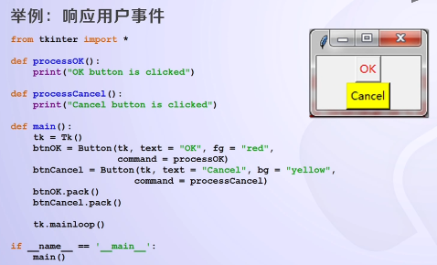

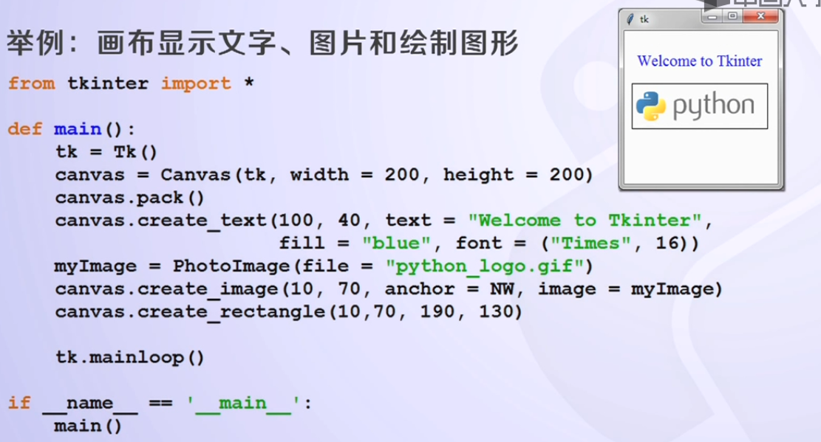

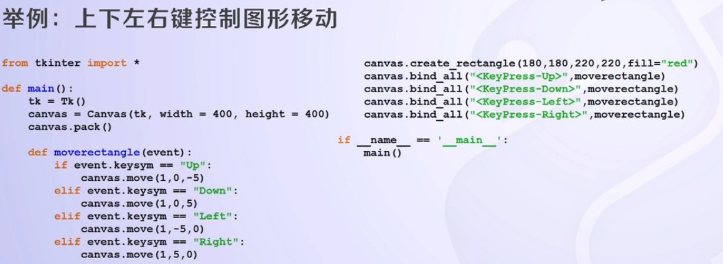

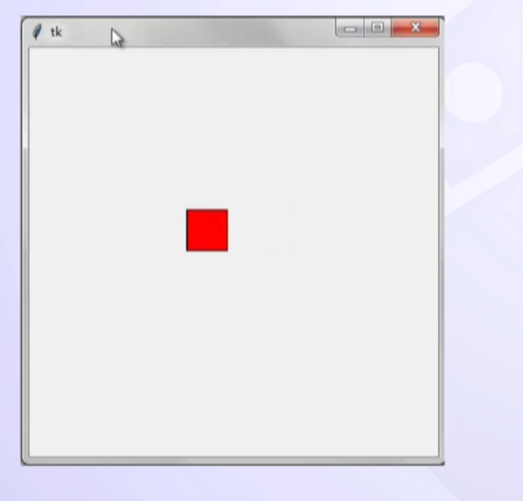

# 图形对象介绍

## GraphWin对象

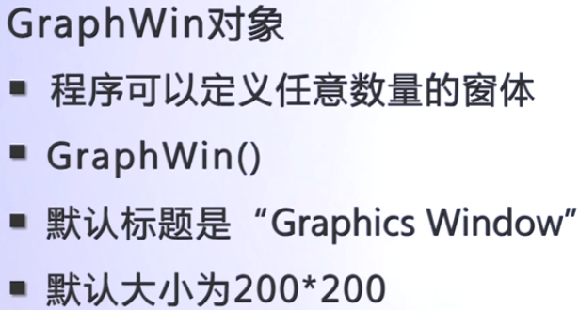

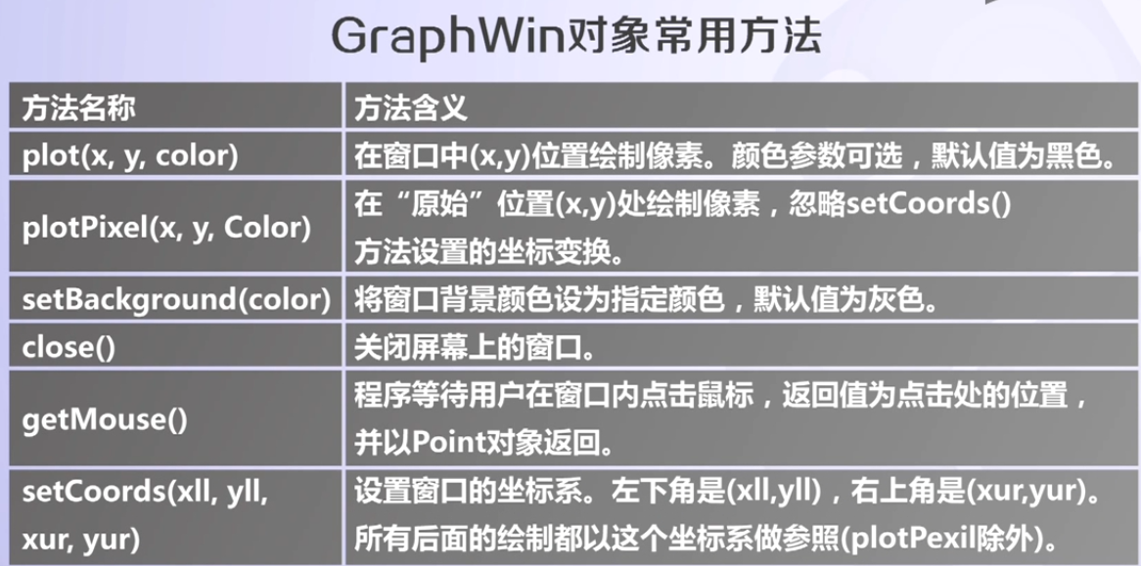

## 图形对象

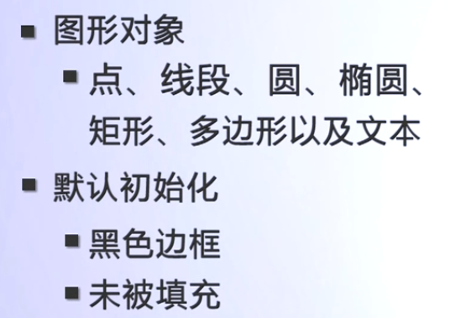

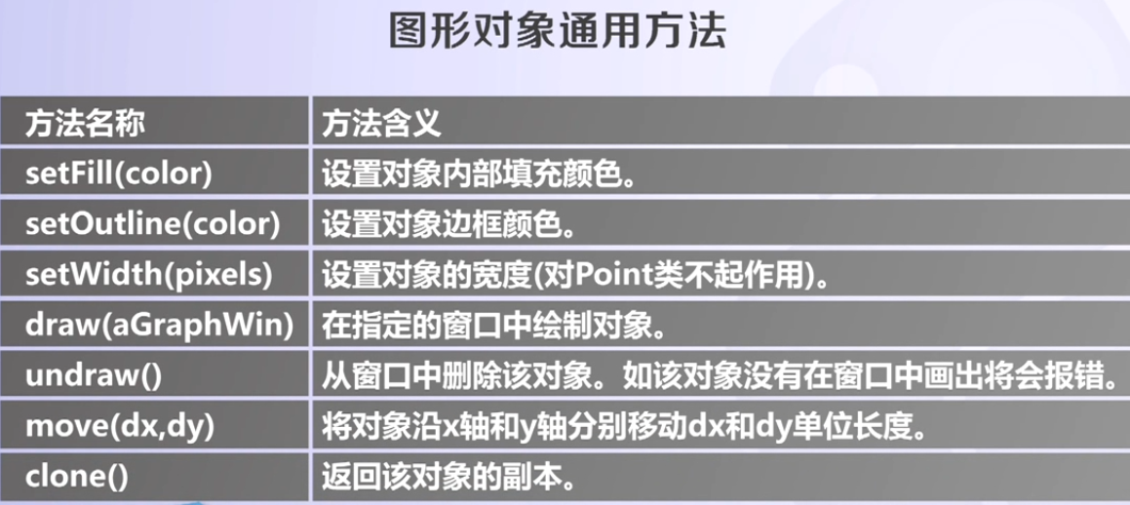

## Point对象

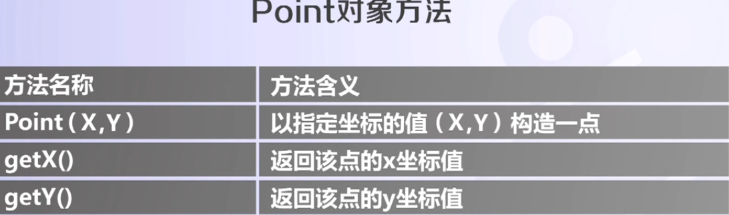

## Line对象

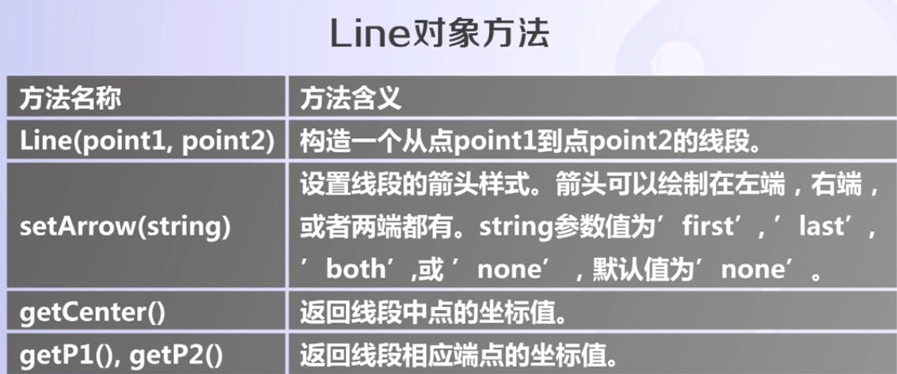

## Circle对象

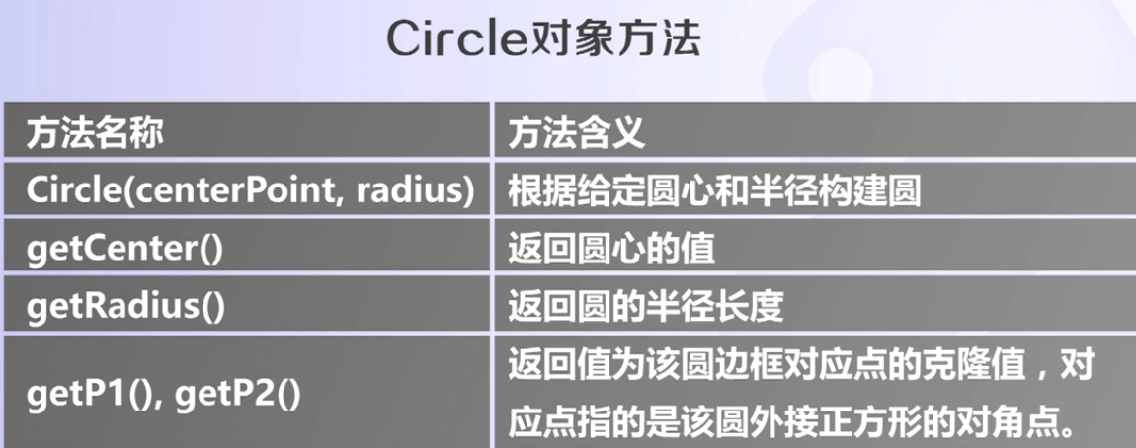

## Rectangle对象

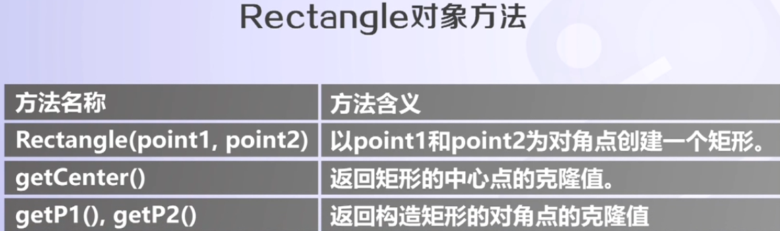

## Oval对象

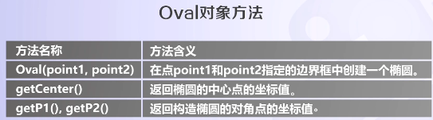

## Polygon对象

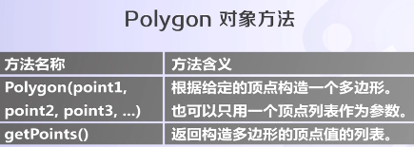

## Text对象

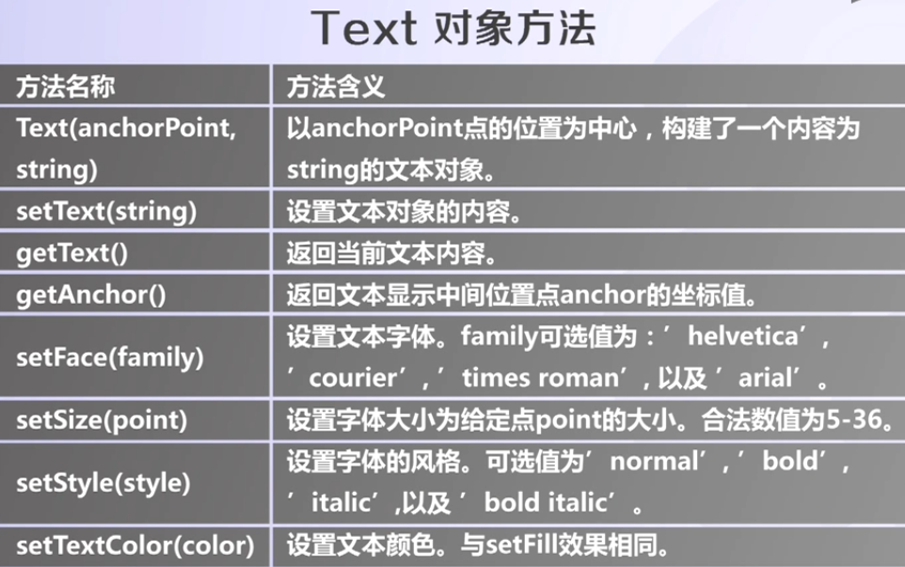

# 图形颜色

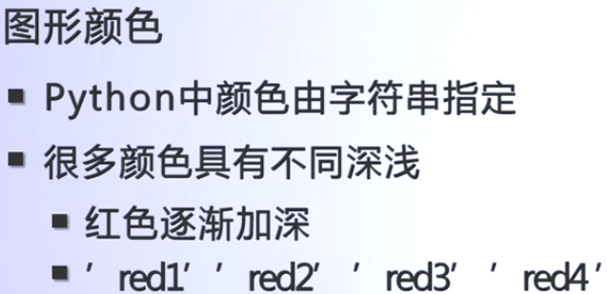

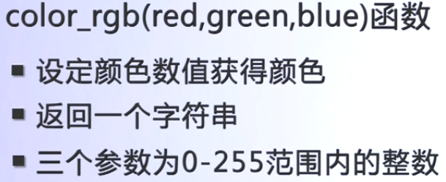

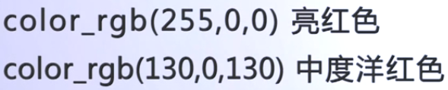

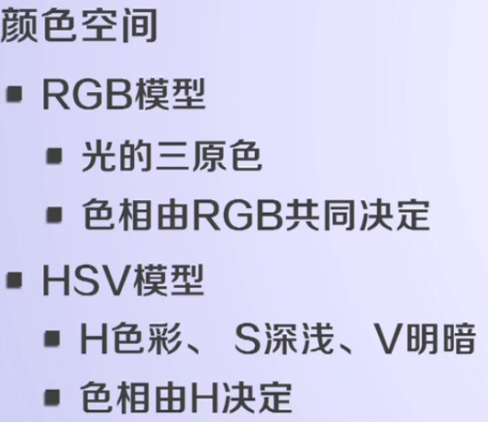

# 简单实例

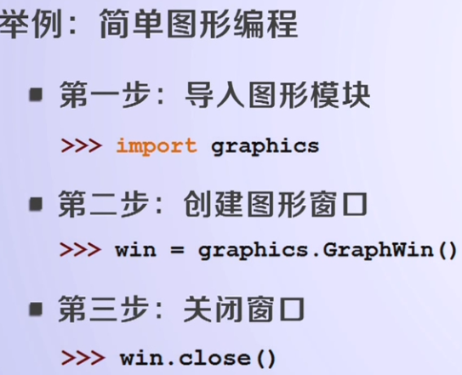

改变导入方式，更简单：

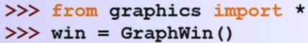

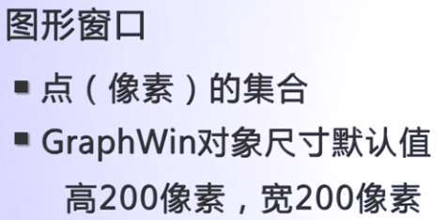

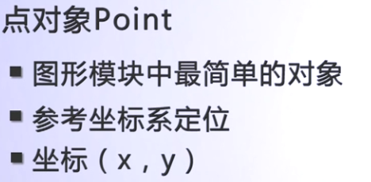

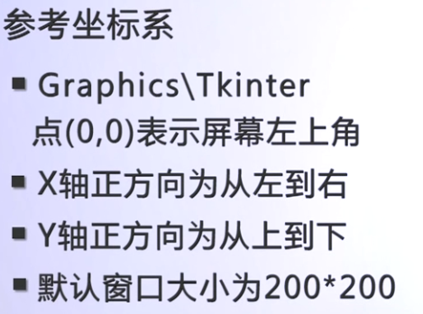

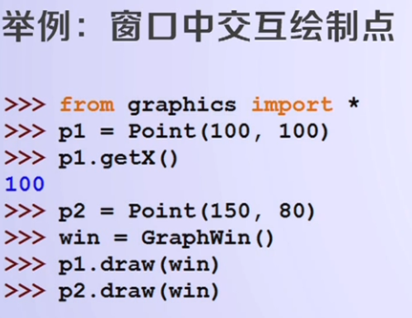

# 图形对象的概念

## Point对象

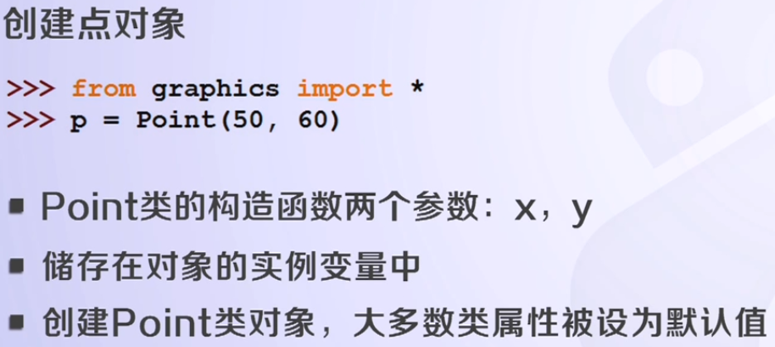

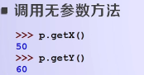

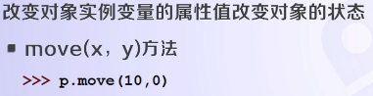

创建一个圆：

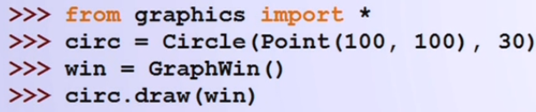

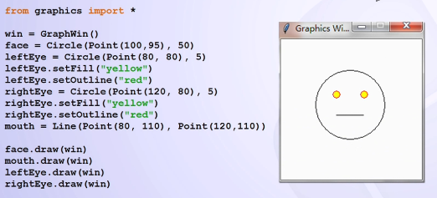

# 实例:

## 温度转换实例

from graphics import *  
  
  
def convert(input):  
 celsius = eval(input.getText())  
 fahrenheit = 9.0 / 5.0 * celsius + 32  
 return fahrenheit  
  
  
def colorChange(win, input):  
 cnum = eval(input.getText())  
 weight = cnum / 100.0  
 newcolor = color_rgb(255 * weight, 66 + 150 * (1 - weight), 255 * (1 - weight))  
 win.setBackground(newcolor)  
  
  
def main():  
 win = GraphWin("Celsius Converter", 400, 300)  
 win.setCoords(0.0, 0.0, 3.0, 4.0)  
 Text(Point(1, 3),  
 " Celsius Temperature:").draw(win)  
 Text(Point(2, 2.7),  
 " (Please input 0.0-100.0 )").draw(win)  
 Text(Point(1, 1),  
 "Fahrenheit Temperature:").draw(win)  
 input = Entry(Point(2, 3), 5)  
 input.setText("0.0")  
 input.draw(win)  
 output = Text(Point(2, 1), "")  
 output.draw(win)  
 button = Text(Point(1.5, 2.0), "Convert It")  
 button.draw(win)  
 rect = Rectangle(Point(1, 1.5), Point(2, 2.5))  
 rect.draw(win)  
 win.getMouse()  
 result = convert(input)  
 output.setText(result)  
 colorChange(win, input)  
 button.setText("Quit")  
 win.getMouse()  
 win.close()  
  
  
if __name__ == '__main__':  
 main()

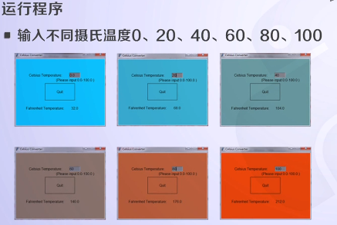

## 聊天窗口实现

